Weld County Colorado Child Care Assistance Program (CCCAP) Income Eligibility Guidelines
Effective October 1, 2023 – September 30, 2024

Family  Size | Gross Income Maximum at Program Entrance | Gross Income Maximum at Program Exit (SMI)
2 | $3,286.67 | $5,709.58
3 | $4,143.33 | $7,053.01
4 | $5,000.00 | $8,396.44
5 | $5,856.67 | $9,739.87
6 | $6,713.33 | $11,083.30
7 | $7,570.00 | $11,335.20
8 | $8,426.67 | $11,587.09
9 | $9,283.33 | $11,838.98

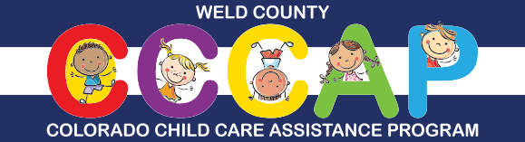
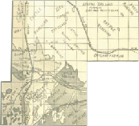
For more information, call the Weld County CCCAP Team at (970) 400-6017 or email HS-CCCAP@weldgov.com
You may also check for eligibility and apply online through the Colorado PEAK® website at www.colorado.gov/PEAK

